

**Tableau Training**

Course-End Project Problem Statement





**Course-End Project: Crime Analysis**

**Problem Scenario:** Crime analysis is important for law-and-order maintenance at any place. It helps the police department and law enforcement agencies to identify patterns of crime, which is crucial for the effective planning of a crime prevention program. The purpose of crime data analysis is to support the operations of the police department, like criminal investigation, apprehension, prosecution, and development of crime prevention and reduction strategies.

**Problem objective:** As a data scientist, you should prepare a dashboard to keep the police department and the city updated on the statistics of crime events. You are required to create a dashboard/story using Tableau for the communication website. Pay attention to data storytelling.

**Note:** Download ***Crime data*** from the course resourcesection in the LMS.

**Variable Description:**

|  |  |
| --- | --- |
| ID | Indicates the unique identifier for the record |
| Case Number | Indicates the police department's case number, which is unique to the incident |
| Date | Indicates the date when the incident occurred. This is sometimes the best estimate |
| Block | Is the partially redacted address where the incident occurred, placed on the same block as the actual address |
| [UCR](https://data.cityofchicago.org/d/c7ck-438e) | Is the Uniform Crime Reporting code, which directly linked to the Primary Type and Description |
| Primary Type | Is the primary description of the UCR code |
| Description | Indicates the secondary description of the UCR code, a subcategory of the primary description |
| Location Description | Is the description of the location where the incident occurred |
| Arrest | Indicates whether an arrest was made |
| Domestic | Indicates whether the incident was domestic |
| [Beat](https://data.cityofchicago.org/d/aerh-rz74) | Indicates the beat where the incident occurred, and the beat is the smallest police geographic area |
| [District](https://data.cityofchicago.org/d/fthy-xz3r) | Indicates the police district where the incident occurred |
| [Ward](https://data.cityofchicago.org/d/sp34-6z76) | Indicates the ward (city council district) where the incident occurred |
| [Community Area](https://data.cityofchicago.org/d/cauq-8yn6) | Indicates the community area where the incident occurred |
| [NIC Code](http://gis.chicagopolice.org/clearmap_crime_sums/crime_types.html) | Indicates the crime classification as National Incident Code |
| X Coordinate | Indicates the x coordinate of the location, where the incident occurred in the state plane |
| Y Coordinate | Indicates the y coordinate of the location, where the incident occurred in state plane |
| Year | Indicates the year the incident occurred |
| Updated On | Indicates the date and time the record was last updated |
| Latitude | Indicates the latitude of the location, where the incident occurred |
| Longitude | Indicates the longitude of the location, where the incident occurred |
| Location | Indicates the location, where the incident occurred in a format that allows for the creation of maps and other geographic operations on this data portal |

**Steps to perform:**

1. Overall Crime Statistics Dashboard:
   1. For personnel and resource management, the department needs to understand the count and types of crimes reported across the city. Mark the locations on a geo-map highlighting the locations with recent criminal history.
   2. Identify the most common criminal incidents reported.
   3. In this introductory dashboard, include a live crime feed to exhibit the total number of crimes reported to date for the current year and the most recently reported crime with their time and locations.

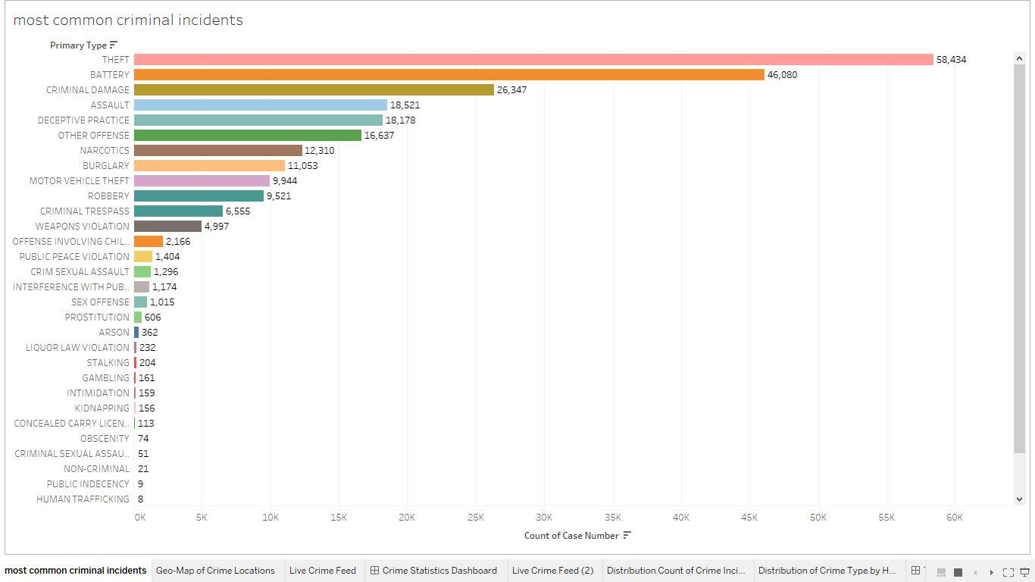

1. Time Period Analysis Dashboard:

Along with locations, the study of crime statistics across time statistics is also crucial for understanding the patterns and planning those preventive strategies.

1. Study distribution count of crime incidents across different time periods such as day of the week or hour.
2. Further explore the percentage of incident reporting for several time blocks (afternoon, evening, early morning, etc.).

1. Trend Analysis Dashboard:
   1. Create a dashboard to study the change in crime rate over different years.
   2. Compare the change in the incident reporting over the years for the same date and time.

1. Comparative Analysis:
   1. Study the distribution of incidents reported where an arrest was made vs. not.
   2. Identify what percentage of the reported incidents under each incident category are domestic.

1. To make the dashboard interactive, provide filters for incident type and location in these dashboards for a granular study.

